ACTIVITY REPORT
Attendance:
___5___ members
_______ non-members
_______ staff
_______ invited guests

Organizer : UTAR Yoga Society & Isha Foundation. __________
Activity Name : Yoga Recruitment Drive FEB session________
Date : 24–26 Feb 2026 (Tuesday) to (Thursday)_________
Time : 10:00am–4:00pm ___________________________
Venue : Multipurpose Hall (MPH), Sungai Long Campus____
Long Campus.

Reported by:

____________ _____SECRETARY_______ _2 FEB 2026__
(Susie)LIM SAIKEAT Designation Date

DESCRIPTION OF THE ACTIVITY

- Executive Summary
UTAR Yoga Society conducted a Recruitment Drive (RD) to promote the FEB session and recruit new members. The event was held at the Multipurpose Hall from 24–26 Feb 2026 (10:00am–4:00pm). Prior to the RD, the committee prepared publicity content and posted promotions on social media, as well as designed and purchased required booth materials. During the RD, the team set up an information booth and engaged students through face-to-face explanations and QR-based registration.
- Outcome
- Recruitment Drive was conducted for 3 days at the Multipurpose Hall.
- 10 new members successfully registered during the event.
- Booth setup and materials were prepared in advance, helping the team run the event smoothly.
- Promotion YOGA Clube and suggest well being activity in SG Long Campus.

Membership recruitment: A total of 10 new members registered during the Recruitment Drive, attendance shown as diagram 4 below.

Activity progress (start → process → end):
- Start: Booth setup at the Multipurpose Hall with promotional materials, QR sign-up, and a committee duty arrangement for greeting and registration support.
- Process: Committee members approached students, introduced the Yoga Society’s activities and benefits, answered questions, and guided interested students to register.
- End: Booth packing, consolidation of registrations, and quick team review of common student questions and responses.
Promotion approach (online + on-site):
- Online publicity: Pre-prepared and posted promotional content across social media before and during the RD to increase awareness and drive traffic to the booth.
- On-site promotion: Booth branding and direct engagement, supported by a simple registration flow (QR code) to reduce sign-up barriers.
Student feedback (informal, based on booth interactions):
- Reasons students were interested: stress relief and wellbeing, flexibility/posture improvement, beginner-friendly nature, and a supportive community environment. Willing to try and interested to trier class.
- Reasons students were not interested: time constraints, perception that yoga is difficult or concerns about flexibility, preference for other clubs/sports, and uncertainty about commitment/logistics.

- Conclusion
The UTAR Yoga Society Recruitment Drive (24–26 Feb 2026) was successfully executed with strong preparation in publicity and booth logistics. The event achieved its main objective by recruiting 5 new members and improving awareness of society through both online promotion and on-site engagement. Future drives can further improve conversion by addressing common concerns early (time, flexibility, beginner confidence) and providing clearer “next step” information such as first-session date/time and participation expectations.

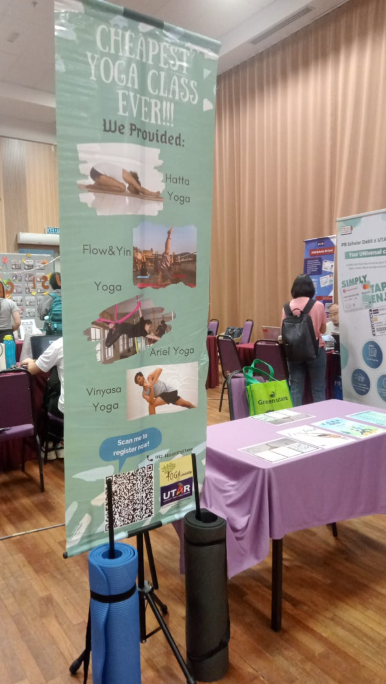  Figure 1: RD booth 24 FEB Day1 | 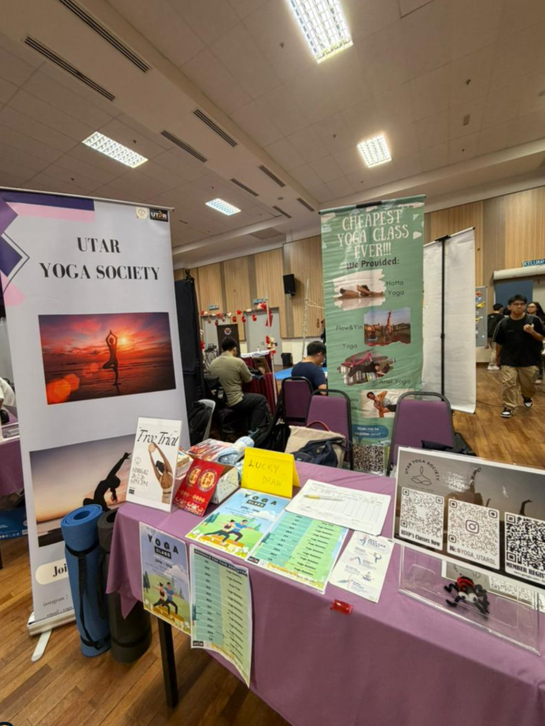  Figure 2: RD booth 26 FEB Day3
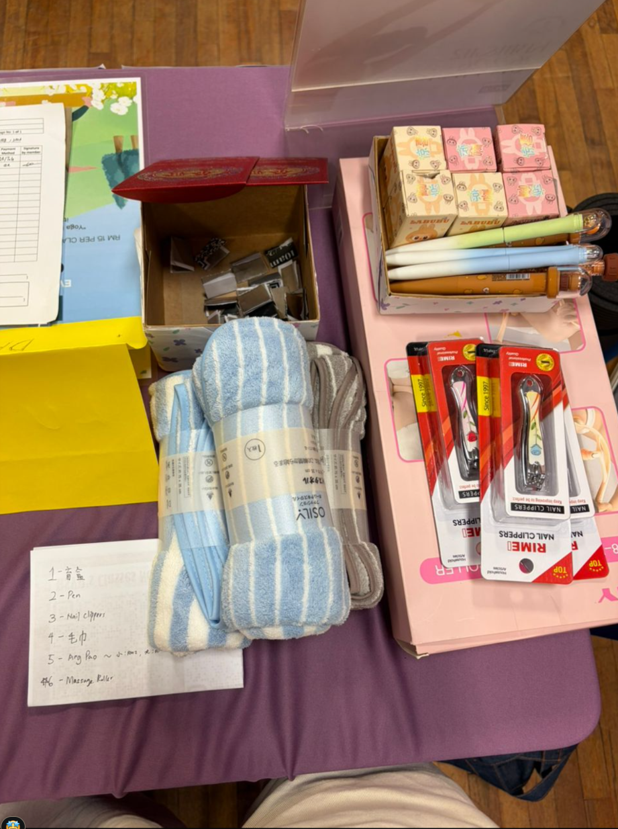
Figure 3: Free gift provided.
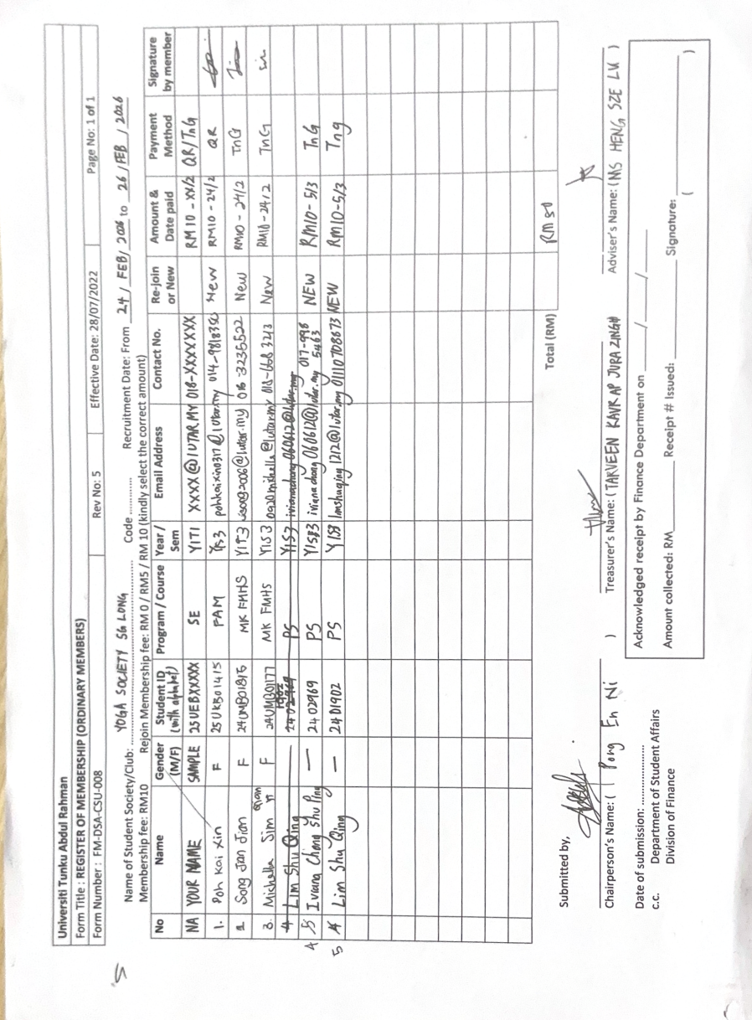
Figure 4: Total new member have successful recruitment.

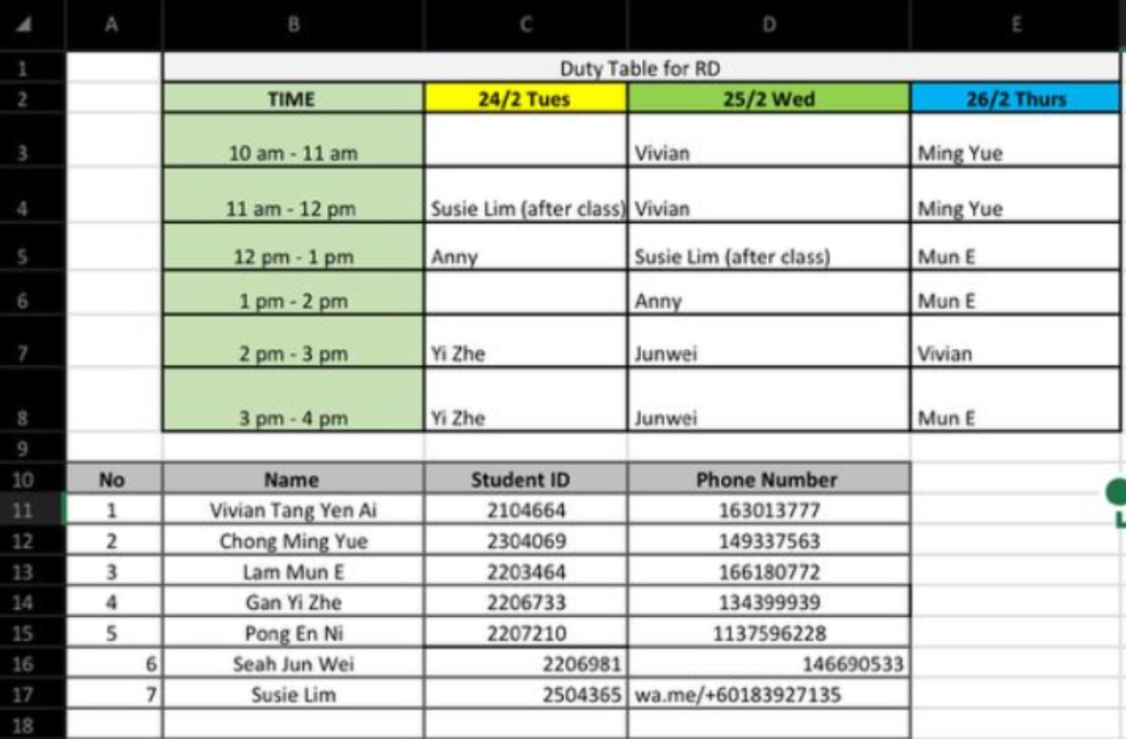
Figure 5: Duty members table

